IC Resistors

Objective
The key concepts introduced in this lab are:
- Structure of Integrated Circuit resistors;
- Calculation of the sheet resistance given the layout of a resistor and the measured resistance;
- Calculation of the resistivity of a material based on the simulations of the technological process of making of an IC resistor;

Prelab
Read Background material in the Appendix at the end of this lab (see example for calculations of the sheet resistance and design).

Procedure
- Calculating the polysilicon sheet resistance.
  - Figure 1 shows a layout of an IC polysilicon resistor (M3520). From the layout (1.5 μm between grid points) find the number of squares for the resistor. Assume that the contact regions at the ends of the resistor count as one square each and use the effective number of squares for right-angle bends where necessary (see Appendix, section 3).
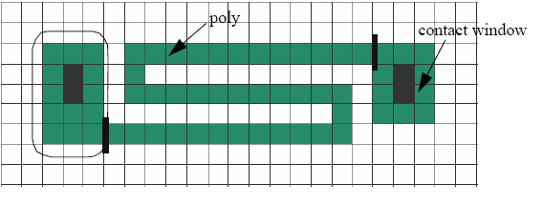
Figure 1. Layout of M3520.

  - Resistor R1 shown in Figure 2 consists of 15 M3520 polysilicon resistors in series, connected by aluminium metal interconnects. Its measured resistance R1 = 48.7 kΩ. Neglecting the contribution of the aluminium metal interconnects and polysilicon-aluminium ohmic contacts, calculate the sheet resistance R_{S} of the polysilicon film.

- Calculating the thickness of polysilicon resistor.
  - Assume that M3520 polysilicon resistor is created using technique described in the Appendix (section 2). Assume the following parameters: substrate material is N-type polysilicon, the concentration of donor atoms (phosphorous) N_{d} = 10¹⁶cm⁻³, P-type polysilicon resistive body is created by diffusion of boron (boron deposition at temperature 900 ⁰C for 2 minutes followed by the drive-in at T = 1100 ⁰C for 120 minutes). Run the “Interactive Mathlab Animations for Understanding Semiconductor Devices”, section 1.3.4: “Visualization of Diffusion Models and Process Simulation” on your PC. Using all the input data given above simulate the diffusion process of the P-type polysilicon resistive body (present the simulated graph showing dopant concentration versus the depth in your lab report).
  - From the graph determine the thickness x_{j} of the polysilicon resistor body.
  - Using the value of x_{j} found in the previous section estimate the resistivity ρ of the P-type polysilicon.

- Calculating the metal sheet resistance.
  - Figure 3 shows a very long metal aluminium runner connecting to two bonding pads (note that Figure 3 is not to scale) The metal runner has resistance R2 = 580 Ω.
  - From the layout in the Figure 3 determine R_{S} of metal. The width of the runner is 3 μm. Assume that the large “chunks” at the pads together contribute about one square and the five turns are approximately the same length for simplicity.

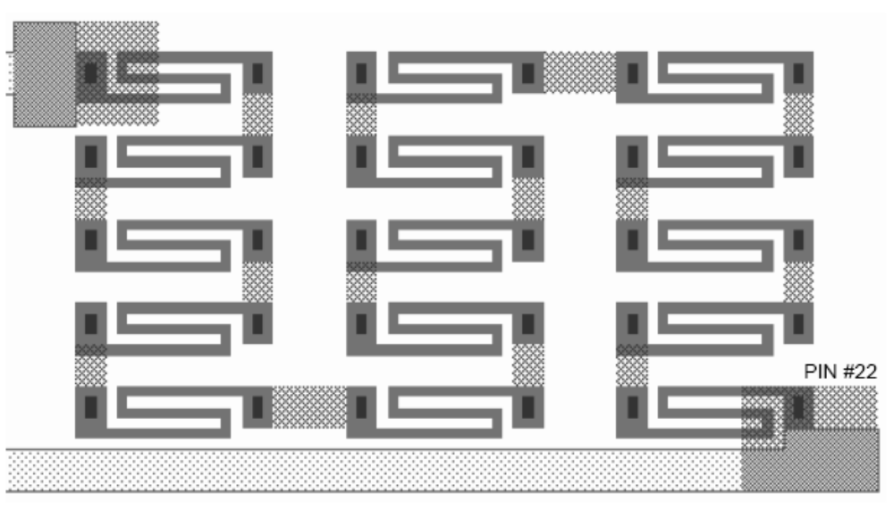
Figure 2. Layout of resistor R1.
Aluminium interconnects
M3520

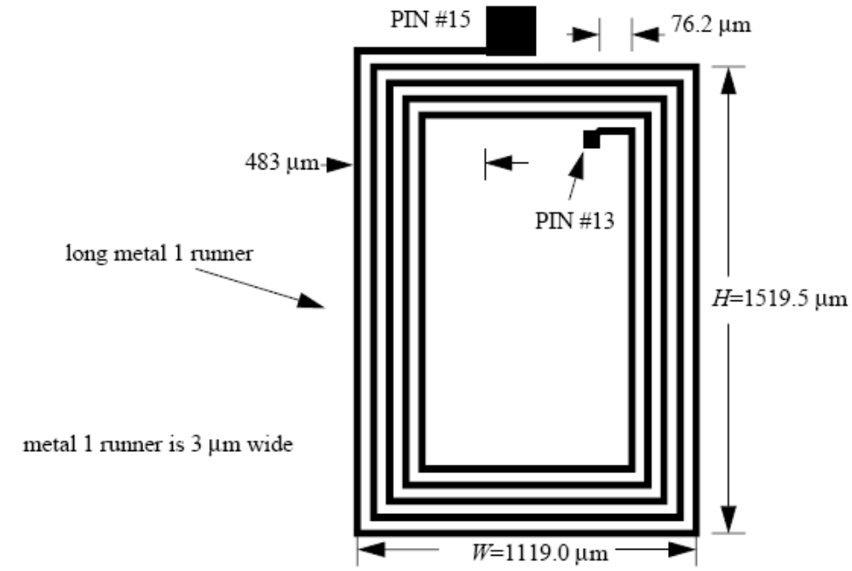
Figure 3. Layout of resistor R2.

APPENDIX

1. Structure of Integrated-Circuit Resistors
Resistors in integrated circuits are made of a resistive body surrounded by an insulating medium, and contacted at the ends by conductive stripes (usually thin metal layers), as shown in Figure 4. The resistance of the resistor depends on the resistive property of the body, called resistivity (ρ), and its dimensions in the following way:
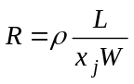
Note that the curved ends of the resistive body are neglected and the resistor shape is considered as a rectangular prism with dimensions L, W, and x_{j}.
The reciprocal value of resistivity, called conductivity, is more frequently used to characterize the resistive/conductive properties of semiconductor layers. The conductivity is denoted by σ, thus
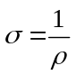
Different resistors in an integrated circuit can have different and independent lengths L and widths W, although there is a minimum dimension that is technologically achievable. The value of the ratio L/W is used to adjust the resistor values while designing integrated circuits. The conductivity (σ) and the thickness of the resistive layer (x_{j}) are technological parameters, and they have the same values for all the resistors made with one type of resistive layer. There will be only a few different types of layers (with different conductivities and thicknesses) available for making resistors. The term 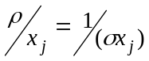 is frequently expressed as one variable called sheet resistance, R_{S}:
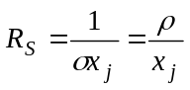
If the resistance of a test resistor with known L and W is measured, the sheet resistance of the associated layer can easily be calculated from the following equation:
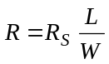

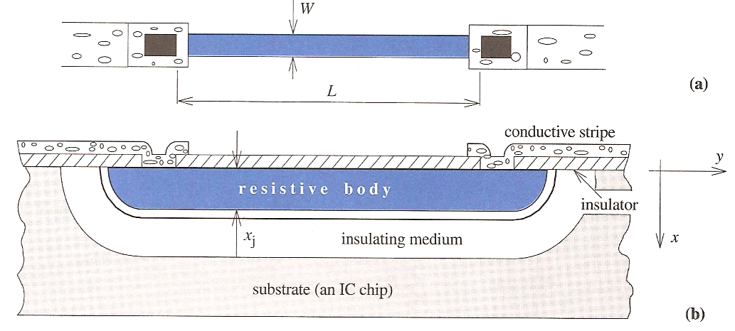

Figure 4. Integrated-circuit resistor: (a) top view and (b) cross section.
Example. Using Sheet Resistance
Design a resistor of 3.5 kΩ using a layer with sheet resistance of 200 Ω/. The minimum dimension achievable by the particular technology is 1 μm.

Solution:
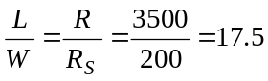
Any combination of L and W that gives the ratio of L/W = 17.5 will provide the needed resistor of 3.5 kΩ. However, a rule in microelectronics states that the performance of the microelectronic circuits is maximised if the device dimensions are minimised. Because of that, the optimum solution is W = 1 μm, and L = 17.5 μm.

2. Making an IC resistor.
Combining the lithography and the diffusion, semiconductor resistors can be made. The process of making a resistor is illustrated in the Interactive Mathlab Animations package (section 1.3.1: “The Concept of Diffusion”).
Let us consider for example an IC resistor where the initial material is N-type silicon with a window in the overlying oxide layer. Let us assume that the concentration of donor atoms in the N-type substrate is N_{d} = 10¹⁶ cm⁻³, as illustrated in Figure 5 by the dashed line. The concentration of the donors is uniform throughout the substrate as this doping is performed while the crystal substrate is being grown. To create a P-type resistive body at the surface, boron diffusion is performed. The boron diffusion will create a non-uniform doping profile as most of the boron atoms incorporated by the diffusion in the silicon will remain at the surface; going deeper into substrate, lower concentrations of the boron atoms will be found (Fig. 5).
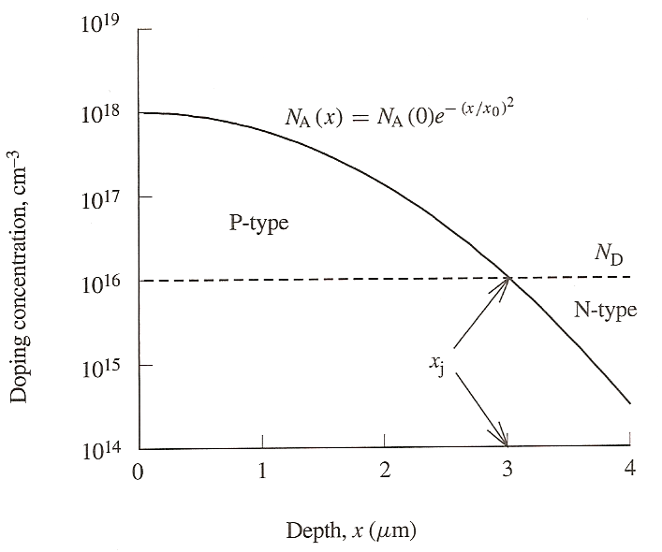
Figure 5. Diffusion of acceptors into an N-type substrate creates a P-N junction: P-type semiconductor between the surface and x_{j}, and an N-type semiconductor from x_{j} into the bulk of the substrate.
If a higher concentration of boron atoms is achieved at the surface (N_{a} = 10¹⁸ cm⁻³), the acceptor-type doping atoms will prevail and the surface of the silicon will appear as P-type. Figure 5 shows that there is a point at which N_{a} = N_{d}. This point is called P-N junction.
The resistive body is a P-type, therefore the holes will be the current carriers in the resistor. For the resistor to function properly, it is necessary to confine the current flow within the P-type resistor body, i.e. not to let any current leak into the N-type substrate. This can be achieved if the N-type substrate is connected to a positive voltage that will repel any hole trying to enter the N-type substrate.
The properties of the diffused layer (the conductivity and the depth) are controlled by the parameters of the diffusion process – temperature and time. If the diffusion is performed at higher temperature and for a longer time, it will enable the doping atoms to penetrate deeper into the semiconductor, which results in a higher conductivity of the diffused layer.

3. Effective number of squares for resistor end and corner

